Characterizing Solar Cells Though Current, Voltage and Power

Group 1

York University

03/04/16

Submitted by:

Lucas Santaguida (212737599)

Jude Furtal (212238010)

Luke Chung (212910667)

Thomas Vacheresse (212974945)

Mark Lopez (212059747)

Henry Vu (213582812)



**Table of Contents**

**List of Variables** 3

**Introduction** 4

**Methods** 5

**Results** 6

**Discussion** 8

**Conclusion** 10

**Work Cited** 11

**Appendix-I – Calculations** 12

**Appendix-II – MATLAB Code** 15

**Appendix-III – Arduino Code** 18

**Appendix-IV – Extra Figures** 19

# **List of Variables**

|  |  |
| --- | --- |
| IL | Light generated current |
| Io | Dark saturation current. The diode leakage current density in the absence of light |
| V | Applied voltage across the terminals of the diode |
| Q | Absolute value of electron charge |
| T | Absolute temperature [K] |
| K | Boltzmann’s constant, 1.38 X 10-23 [m2 kg s-2 K-1] |
| Imp | Current at maximum power |
| Vmp | Voltage at maximum power |
| Isc | Short circuit current |
| Voc | Open circuit voltage |

# **Introduction**

Photovoltaic cells (PV), or more commonly known as solar cells, are an increasing part of everyday life. Whether it is for powering homes or for powering satellites, photovoltaic cells are paving the way for a clean and sustainable source of power. The increasing importance of solar cells in everyday use necessitates a thorough understanding of their capabilities, allowing us to maximize the usage of each cell. The goal of this project was to assess the data acquisition of the Arduino UNO through measuring voltages of a circuit powered by a solar cell. By doing so, we aim to distinguish three solar cells, varying in size and composition, through their current-voltage (I-V) curve. A quantitative comparison with online datasheets for the three solar cells will also be performed, where accurate results are defined as being consistent with datasheet measurements. The fill factor (FF) of the solar cells is used for comparison and is expressed as

|  |  |  |  |
| --- | --- | --- | --- |
| |  |  | | --- | --- | | = | (1) | |  |

The fill factor is a unit less quantity that represents of the square-ness of the I-V curve, as seen in Figure 1. This factor allows for a comparison of how the solar cell is operating from its ideal value. The x-intercept of the I-V curve shown in Figure 1 is the short circuit current where there is no voltage in the system, and the y-intercept is the open circuit voltage where there is no current. For solar cells, the relationship between voltage and current is explained by the photovoltaic effect. This effect involves the increase of charge carriers which reduces the net electric field by charge separation (PV Education).

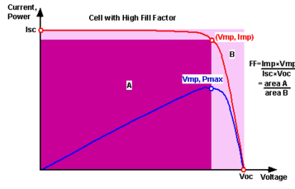

Figure 1: Pictorial representation of the Fill Factor (PV Education)

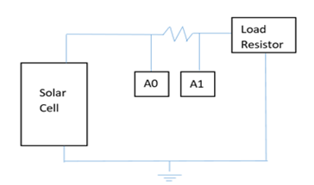**Methods**

Measuring voltage

For this experiment, the circuit illustrated in Figure 2 was constructed using a solar cell and a 2.1 Ω resistor. A lamp was placed directly above the solar cell to serve as incident light, and a fan was used to prevent the solar cells from heating up. Next, the voltage values at A0 and A1 as well as their differences were recorded using the two analog reads on the Arduino (see Appendix-III for Arduino code). After each measurement, the resistance of the circuit was varied using the load resistor and the resulting voltage was recorded. The change in resistance effectively changes the amount of current. Voltage measurements were obtained until the voltage difference between A0 and A1 reached zero. Using Ohm’s law (I = ΔV/R = ΔV /(2.1 Ω)), the current was calculated for each voltage difference and plotted as a function of the voltage at A0. This voltage represents the output voltage of the solar cell. The above process was repeated for the other two solar cells.

Figure 2: Circuit diagram of constructed circuit

Curve fitting – least squares nonlinear parametric regression (see Appendix-II for MATLAB code)

The measured currents and voltages from the solar cells were fitted according to the equation for the general current-voltage (I-V) curve. The general equation was simplified such that only constant values A, B and C needed to be determined:

|  |  |
| --- | --- |
| $$I=I_{L} -I_{0}\left[\exp\left(\frac{q}{nkT}*V\right)\right] → I=A -B \left[\exp\left(C*V\right)\right]$$ | (2) |

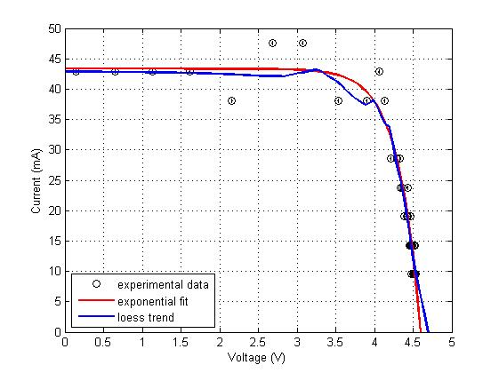The power curve for each solar panel was obtained from the fitted curve using $P=I*V$, where a linearly spaced vector of voltage values was used. As a reality check, the parametric model was compared to the local regression fit. As seen in the figure below, the shape of both I-V curves are fairly consistent with one another. To first order, this confirmed that our model was valid.

Figure 3: I-V curves obtained by both parametric and nonparametric regression for the largest solar cell (see Appendix-IV for regression comparisons for the other solar cells)

# **Results**

Table 1: Maximum power from the fitted power curve of each solar cell with the corresponding voltage and current values. The open circuit voltage and short circuit current (i.e. the x- and y-intercepts) are also shown. All values are displayed with their corresponding uncertainty which was rounded to match the number of decimal places of the actual value.

|  |  |  |  |  |  |  |  |
| --- | --- | --- | --- | --- | --- | --- | --- |
| **Solar Cell** | **Pmax [mW]** | **Voc[V]** | **Isc [mA]** | **Vmp[V]** | **Imp [mA]** | **FF** | **FF % Difference** |
| **IXYS (small sized)** | $$33.49±0.55$$ | $$2.46±0.01$$ | $$19.05±0.55$$ | $$1.99±0.01$$ | $$16.83±0.55$$ | $$0.715±0.047$$ | 0.99% |
| **SPECTROLAB (medium sized)** | $$54.31±0.55$$ | $$2.30±0.01$$ | $$30.66±0.55$$ | $$1.85±0.01$$ | $$29.41±0.55$$ | $$0.78±0.020$$ | 7.58% |
| **MIKROE (largest)** | $$155.74±0.30$$ | $$4.51±0.01$$ | $$42.86±0.30$$ | $$3.84±0.01$$ | $$40.56±0.30$$ | $$0.806±0.010$$ | 2.66% |

The figures below show the I-V curves and power curves of the three solar cells. The short circuit current, open circuit voltage, and other values used for comparison are specified in the table above. The square-like shape was obtained for the I-V curve of all three solar cells with varying square-ness (i.e. varying FFs).

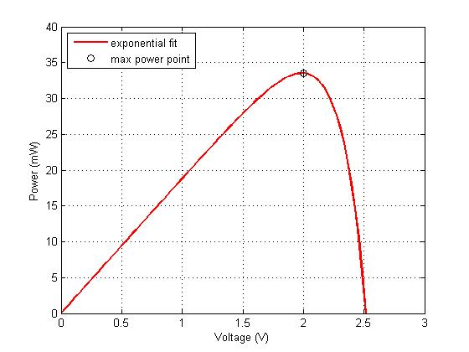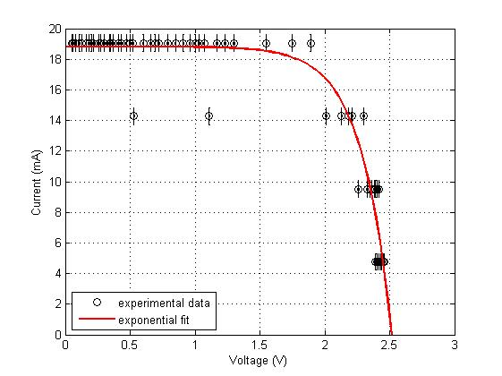

Figure 4: IXYS I-V curve Figure 5: IXYS power curve

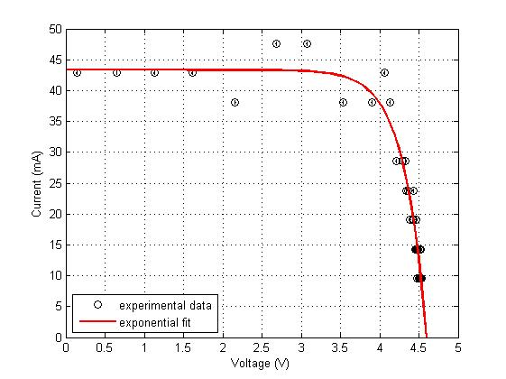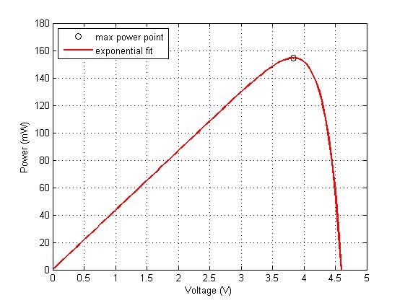

Figure 6: MIKROE I-V curve Figure 7: MIKROE power curve

The experiment was repeated for the SPECTROLAB solar cell since the fitted I-V curve from our presentation results displayed large deviation from the online datasheet. For the new run, one of the two bulbs on the light source burnt out and reduced the intensity of the light. Also, the new data was gathered more quickly to further prevent the solar cell from heating up.

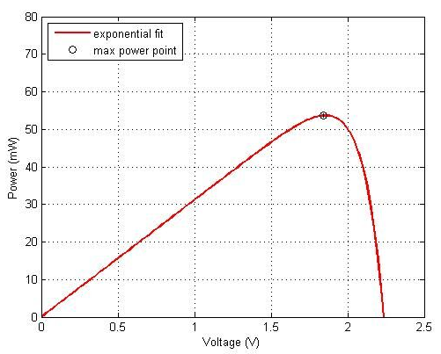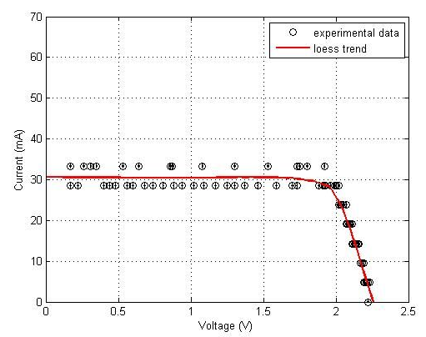

Figure 8: SPECTROLAB I-V curve Figure 9: SPECTROLAB power curve

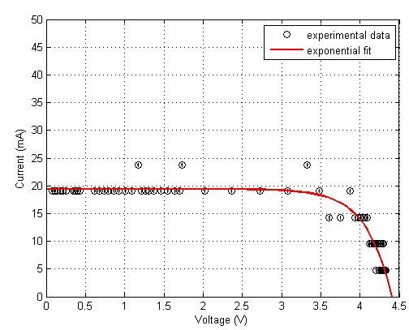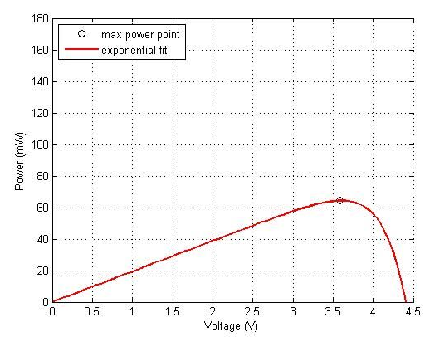The experiment was also repeated for the MIKROE solar cell, but instead with a plastic bag covering the solar cell to reduce the intensity of the light from the halogen lamp. The shielding of the lamp reduced the maximum solar cell current by ~23 mA.

Figure 11: MIKROE power curve with reduced intensity

Figure 10: MIKROE I-V curve with reduced intensity

# 

# **Discussion**

From the results, it is clear that the current produced by the solar cells are significantly low compared to the datasheet values. This can be explained by differences in intensity, spectrum of incident light, and temperature.

The short circuit current (ISC) of solar cells, represented by the y-intercept of the I-V curve, has a power law dependence upon light intensity (Koster et al., 2005). The short circuit current density JSC, which is simply ISC divided by the effective surface area of the solar cell, can be described by JSC . For most solar cells, the exponent $α$ varies between 0.85 and 1 based on the composition of the solar cell and presumably other factors. The datasheets for the solar cells used in our experiment did not specify $α$ or the light intensity that was used to obtain their solar cell measurements. Thus, the parameters used for obtaining our experimental data likely did not match that which was used for the datasheet. This may explain the significant differences in short circuit current between the datasheets and our obtained measurements. (Figure 10 and 11 were experimental runs where the MIKROE was shielded to reduce intensity which also reduced the current)

The spectrum of incident light (i.e. the power input for each wavelength of light) is also important to consider when making solar cell measurements. Since the spectra of incident light are not specified in the solar cell datasheets, it can be concluded that the inaccuracy of the experimental data is partly due to the difference in lighting conditions. Solar cell measurements are usually performed using a standard spectrum of light and there is also a standard that is used for space applications, which was presumably used for the SPECTROLAB solar cell datasheet. The experimental data for this project was obtained using a halogen lamp, which is known to vary greatly from the two aforementioned standards. One could potentially obtain more accurate results by using a light source that radiates the appropriate spectrum. The performance of a solar cell is reflected by factors such as spectral responsivity (SR) and efficiency ($η$), both of which depend on solar power input (Pin). The involvement of current in these factors can be shown by the following equations:

|  |  |
| --- | --- |
| $SR= \frac{I_{SC}}{P_{in}}$& $η= \frac{P_{out}}{P_{in}}$ | (3) |

For a given SR which can be calculated from the datasheet measurements, ISC would vary based on Pin. Likewise, for a given efficiency (provided in two of the three online datasheets), the power curve (Pout) and therefore the current would also vary depending on the solar power input. The solar power input varies for different forms of incident light and so the halogen lamp is expected to produce different current from another different light source. This highlights the importance of using similar lighting conditions when comparing solar cells.

In our presentation results, it was observed that the SPECTROLAB solar cell I-V curve was bowed inwards, potentially due to the increased temperature of the solar cell during data collection. The solar cell experienced an increased temperature due to a mistake in the construction of the circuit. The experiment needed to be completed again, thus doubling the duration in the light of the lamp. It can be seen from equation (2) that the temperature is a factor that can change in the exponential term. With increased temperature more electrons become free. The reason for this is the temperature excites electrons in the atoms, and thus requiring less energy to break free from the bounded atoms. The larger current thus reduces the voltage the cell can produce as explained in the background section. The result is the bowing inwards of the IV curve.

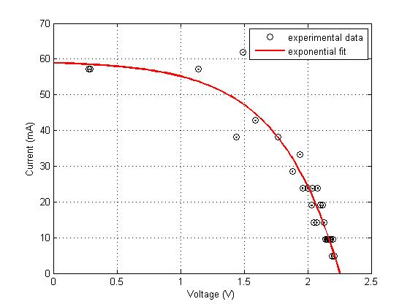

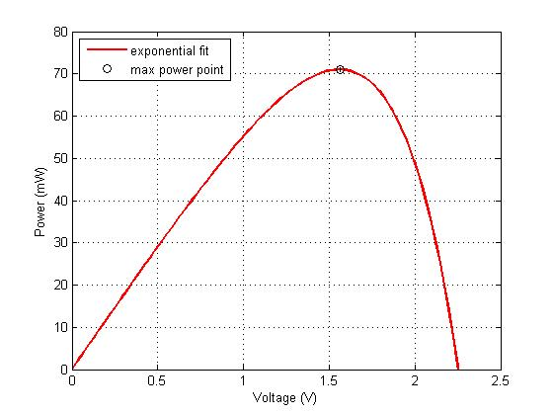

Figure 12: SPECTROLAB I-V curve with temperature increase

Figure 13: SPECTROLAB power curve with temperature increase

# 

# **Conclusion**

Photovoltaic cells, due to their increased use, are now and will continue to be an important part of modern technology. It is important to understand how the relationships between the maximum voltage and power output relate to the performance of the cell. We have shown that variations in the intensity cause large shifts in the power output. Alone, the understanding of a maximum output is critical for effectively use of solar cells. A firm grasp on the fill factor, relating measurements to theoretical values, creates a way for comparing how effective individual cells can be. It is equally important to fully understand the limitations of a cell, whereby inferring whether or not outside variables will affect measurements. Variables such as temperature can cause problems in the classification of a cell. This and more allows for a prospect of predictability to an increasingly useful and prevalent technology.

# **Work Cited**

Bergevin, C., 2016. Retrieved April 03, 2016, from

http://www.yorku.ca/cberge/2030W2016.html

Illumination Sources. (n.d.). Retrieved April 03, 2016, from http://www.pveducation.org/pvcdrom/characterisation/illumination-sources

Koster, L. J. A. and Mihailetchi, V. D. and Xie, H. and Blom, P. W. M., Origin of the light intensity dependence of the short-circuit current of polymer/fullerene solar cells, Applied Physics Letters, 87, 203502 (2005), DOI:http://dx.doi.org/10.1063/1.2130396

National Instruments, Photovoltaic Cells, 2009. Retrieved April 03, 2016, from

http://www.ni.com/white-paper/7229/en/

Studying the effect of spectral variations intensity of the incident solar radiation on the Si solar cells performance. (n.d.). Retrieved April 03, 2016, from http://www.sciencedirect.com/science/article/pii/S2090997712000223

The Behavior of Solar Cells, 2007. Retrieved April 03, 2016, from http://www.eng.uc.edu/~beaucag/Classes/SolarPowerForAfrica/BookPartsPVTechnical/Behavior%20of%20PV_03.pdf

# **Appendix-I – Calculations**

**Experimental Fill Factor (FF) for All Three Solar Panels**

IXYS Solar Panel

Pmax = (33.49 ± 0.55) mW, Vmp = (1.99 ± 0.005) V

Isc = (19.05 ± 0.55) mA, Voc = (2.46 ± 0.005) V

$FF= \frac{Pmax}{Isc ×Voc} = \frac{(33.49 ± 0.55)}{(19.05 ± 0.55)(2.46 ± 0.005)}≅0.715$ ± 0.047

MIKROE Solar Panel

Pmax = (155.74 ± 0.3) mW, Vmp = (3.84 ± 0.005) V

Isc = (42.86 ± 0.3) mA, Voc = (4.51 ± 0.005) V

$FF= \frac{Pmax}{Isc ×Voc}= \frac{(155.74 ± 0.3)}{(42.86 ± 0.3)(4.51 ± 0.005)}≅0.806$ ± 0.010

SPECTROLAB solar cell

Pmax = (54.31 ± 0.55) mW, Voc = (2.3 ± 0.005) V, Isc = (30.66 ± 0.55) mA

$FF= \frac{Pmax}{Isc ×Voc}= \frac{(54.31 ± 0.55) }{(30.66 ± 0.55)(2.3 ± 0.55) }≅0.78$ ± 0.02

**Data Sheet Fill Factors for All Three Solar Panels**

IXYS Solar Panel

Pmax = (89.2 ± 0.05) mW, Voc = (2.52 ± 0.005) V, Isc = (50.0 ± 0.05) mA

$FF= \frac{Pmax}{Isc ×Voc}= \frac{(89.2 ± 0.05) }{(50.0 ± 0.05)(2.52 ± 0.005) }≅0.708$ ± 0.003

MIKROE Solar Panel

Pmax = (400 ± 32) mW, Voc = (4.6 ± 0.368) V, Isc = (105 ± 8.4) mA

$FF= \frac{Pmax}{Isc ×Voc}= \frac{(400 ± 32) }{(105 ± 8.4)(4.6 ± 0.368) }≅0.83$ ± 0.24

SPECROLAB Solar Panel

Vmp = (2.350 ± 0.0005) V, Imp = (0.43358 ± 0.005) A, Voc = (2.660 ± 0.0005) V, Isc = (0.453871 ± 0.005) A

$$FF= \frac{Imp ×Vmp}{Isc ×Voc}= \frac{(0.43358 ± 0.005)(2.350 ± 0.0005)}{(0.453871 ± 0.005)(2.660 ± 0.0005)}≅0.8440±0.0230$$

**Percentage Error for All Three Solar Panels**

IXYS Solar Panel

$$percent error = \frac{|0.715-0.708|}{0.708} ×100\%=0.99\%$$

MIKROE Solar Panel

$$percent error = \frac{\left|0.806-0.828\right|}{0.828} ×100\%=2.66\%$$

SPECTROLAB solar Panel

$$percent error = \frac{|0.780-0.844|}{0.844} ×100\%=7.58\%$$

SPECTROLAB Solar Panel Experimental-Temperature Deviation

Pmax = (71.22 ± 0.55) mW, Vmp = (1.56 ± 0.005) V

Isc = (57.14 ± 0.55) mA, Voc = (2.2 ± 0.005) V

$FF= \frac{Pmax}{Isc ×Voc}= \frac{(71.22 ± 0.55)}{(57.14 ± 0.55) (2.2 ± 0.005) }≅0.57$ ± 0.02

SPECTROLAB Solar Panel Datasheet

Vmp = (2.350 ± 0.0005) V, Imp = (0.43358 ± 0.005) A, Voc = (2.660 ± 0.0005) V, Isc = (0.453871 ± 0.005) A

$$FF= \frac{Imp ×Vmp}{Isc ×Voc}= \frac{(0.43358 ± 0.005)(2.350 ± 0.0005)}{(0.453871 ± 0.005)(2.660 ± 0.0005)}≅0.8440±0.0230$$

SPECTROLAB Solar Panel-Temperature Deviation

$$percent error = \frac{|0.567-0.844|}{0.844} ×100\%=32.82\%$$

It can be seen from the percentage error that the temperature deviated the fill factor from the datasheet expected value.

MIKROE solar cell- Reduced Intensity

Pmax = (65.76 ± 0.30) mW, Voc = (4.40 ± 0.005) V, Isc = (19.49 ± 0.30) mA

$FF= \frac{Pmax}{Isc ×Voc}= \frac{(65.74 ± 0.3)}{(19.49 ± 0.3)(4.40 ± 0.005)}≅0.767$ ± 0.010

MIKROE solar cell- Reduced Intensity

$$percent error = \frac{\left|0.767-0.828\right|}{0.828} ×100\%=7.37\%$$

# **Appendix-II – MATLAB Code**

%% PHYS 2030 Group project - data plots

%% MIKROE Solar Cell (largest size)

large_data = textread('Largepanel_data.txt', '%f'); % measured data

% Separate voltage and current readings - txt file in the form

% [v1; i1; v2; i2;...]

v = large_data(1:2:end); i = large_data(2:2:end);

vv = linspace(0, 5, 100); % x-values for curve fitting

ierr = textread('Largepanel_err.txt', '%f'); % uncertainty from Arduino and resistor

ierr1 = max(ierr)*ones(numel(i), 1); % largest uncertainty value from above was used

verr = 0.005*ones(numel(v), 1); % uncertainty from Arduino

% Nonlinear parametric regression

p0 = [1 1 50]; % initial parameters for lsqcurvefit.m

p = lsqcurvefit(@ivcurve, p0, v, i); % built-in MATLAB function for curve fitting

i_nonlinreg = @(x)(-p(1)*exp(p(2)*x) + p(3)); % model for data (based on general IV curve equation)

ii = i_nonlinreg(vv);

% ---

% visualize exponential fit over experimental data

figure

errorbarxy(v, i, verr, ierr1, {'ko', 'k', 'k'}); hold on; grid on

plot(vv, ii, 'r-', 'LineWidth', 2)

xlabel('Voltage (V)'); ylabel('Current (mA)')

legend('experimental data','exponential fit','Location','SouthWest');

ylim([0 50])

% Power curve (based on exponential fit)

pow = ii.*vv;

m1 = (pow == max(pow)); % find index associated with max power

pmax = sum(m1.*pow);

vpmax = sum(m1.*vv); % voltage corresponding to max power

figure

errorbarxy(vpmax, pmax, 0, 0.55, {'ko', 'k', 'k'}); hold on; grid on

plot(vv, pow, 'r-','LineWidth',2)

xlabel('Voltage (V)'); ylabel('Power (mW)')

legend('max power point', 'exponential fit', 'Location', 'NorthWest')

ylim([0 180])

% LOESS non-parametric regression (from EXloess1.m)

N = 100; % # of points for fit (over interval [min(x) max(x)])

xR = [0 5]; % range of x-values

alpha = 0.5; % loess fit parameter (between 0 and 1)

order = 1; % order of polynomial for fit

% ---

xFit= linspace(min(xR),max(xR),N); % can 'resample' if desired (i.e., need not have xFit=x)

yFit= loess(v,i,xFit,alpha,order,[],1,0,0.1); % loess fit via external function

% ---

% visualize loess fit over experimental data

figure

errorbarxy(v, i, verr, ierr1, {'ko', 'k', 'k'}); hold on; grid on;

plot(xFit,yFit,'r-','LineWidth',2);

xlabel('Voltage (V)'); ylabel('Current (mA)')

legend('experimental data','loess trend','Location','SouthWest');

ylim([0 50])

%% SPECTROLAB Solar Cell (medium sized)

prof_data = textread('Profpanel_dataf1.txt', '%f'); % measured data

% Separate voltage and current readings - txt file in the form

% [v1; i1; v2; i2;...]

v = prof_data(1:2:end); i = prof_data(2:2:end);

vv = linspace(0, 2.5, 100); % x-values for curve fitting

ierr = textread('Profpanel_errf1.txt', '%f'); % uncertainty from Arduino and resistor

ierr1 = max(ierr)*ones(numel(i), 1); % largest uncertainty value from above was used

verr = 0.005*ones(numel(v), 1); % uncertainty from Arduino

% Nonlinear parametric regression

p0 = [1 1 50]; % initial parameters for lsqcurvefit.m

p = lsqcurvefit(@ivcurve, p0, v, i); % built-in MATLAB function for curve fitting

i_nonlinreg = @(x)(-p(1)*exp(p(2)*x) + p(3)); % model for data (based on general IV curve equation)

ii = i_nonlinreg(vv);

% ---

% visualize exponential fit over experimental data

figure

errorbarxy(v, i, verr, ierr1, {'ko', 'k', 'k'}); hold on; grid on

plot(vv,ii,'r-','LineWidth',2)

legend('experimental data','exponential fit','Location','NorthEast');

ylim([0 70])

prof_deplot = textread('Profpanel_deplot1.txt', '%f'); % IV curve data from datasheet

x1 = prof_deplot(1:3:end); y1 = 26.62*prof_deplot(2:3:end);

% ---

% visualize exponential fit and deplot curve over experimental data

figure

errorbarxy(v, i, verr, ierr1, {'ko', 'k', 'k'}); hold on; grid on

plot(vv,ii,'r-','LineWidth',2)

plot(x1, y1, 'LineWidth', 2)

xlabel('Voltage (V)'); ylabel('Current (mA)')

legend('experimental data','exponential fit','datasheet', 'Location','NorthEast');

xlim([0 3]); ylim([0 525])

% Power curve (based on exponential fit)

figure

pow = ii.*vv;

m1 = (pow == max(pow)); % find index associated with max power

pmax = sum(m1.*pow);

vpmax = sum(m1.*vv); % voltage corresponding to max power

plot(vv, pow, 'r-','LineWidth',2); hold on; grid on

errorbarxy(vpmax, pmax, 0, 0.55, {'ko', 'k', 'k'})

xlabel('Voltage (V)'); ylabel('Power (mW)')

legend('exponential fit', 'max power point', 'Location', 'NorthWest')

ylim([0 80])

% LOESS non-parametric regression

N= 100; % # of points for fit (over interval [min(x) max(x)])

xR= [0 2.5]; % range of x-values

alpha= 0.5; % loess fit parameter (between 0 and 1)

order= 1; % order of polynomial for fit

% ---

xFit= linspace(min(xR),max(xR),N); % can 'resample' if desired (i.e., need not have xFit=x)

yFit= loess(v,i,xFit,alpha,order,[],1,0,0.1); % loess fit via external function

% ---

% visualize loess fit over experimental data

figure

errorbarxy(v, i, verr, ierr1, {'ko', 'k', 'k'}); hold on; grid on;

plot(xFit,yFit,'r-','LineWidth',2);

xlabel('Voltage (V)'); ylabel('Current (mA)')

legend('experimental data','loess trend','Location','NorthEast');

ylim([0 70])

NOTE: The lines of code above were repeated for other data sets (i.e. the file read by textread.m was changed, in addition to other minor changes). The code required for plotting the small panel data was done using the code above for the large panel (with few alterations). Built-in functions from the course website were also used (EXloess1.zip).

# **Appendix-III – Arduino Code**

/*

ReadAnalogVoltage

Reads an analog input on A0 and A1. A0 is the voltage output

of the solar cell. The program computes the difference in the

voltages by subtracting A0 and A1.

*/

// the setup routine runs once when you press reset:

void setup() {

// initialize serial communication at 9600 bits per second:

Serial.begin(9600);

}

// the loop routine runs over and over again forever:

void loop() {

int sensorValue = analogRead(0);// read the input on analog pin 0:

delay(500);// Requiers minimum 10ns delay or results will have error

int sensorValue2=analogRead(1);// read the input on analog pin 1;

// Convert the analog reading (which goes from 0 - 1023) to a voltage (0 - 3V):

float voltage = sensorValue * (5 / 1023.0);

float voltage2 = sensorValue2 * (5 / 1023.0);

float diff=voltage-voltage2; // computes the difference in the voltage

// print out the value you read:

Serial.print(voltage);

Serial.print(" ");

Serial.print(voltage2);

Serial.print(" ");

Serial.print(diff);

Serial.println();

delay(2500); // delay to allow for variable resistor to be changed.

}

# 

# **Appendix-IV – Extra Figures**

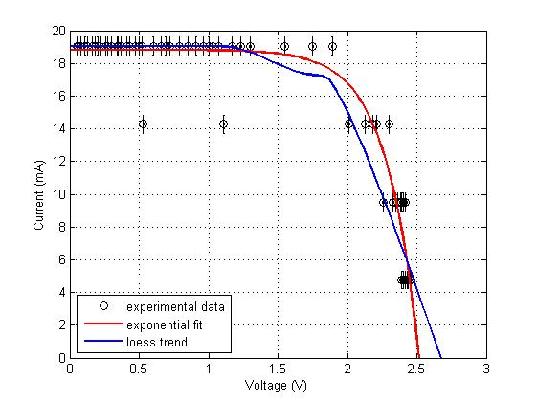

Figure 14: IXYS I-V curves obtained by both parametric and nonparametric regression

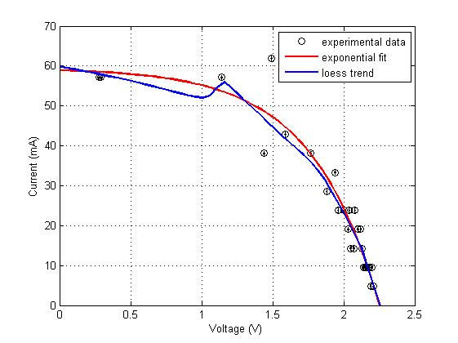

Figure 15: SPECTROLAB I-V curves obtained by both parametric and nonparametric regression